

SNELLS BEACH SCHOOL PARENT CONSULTATION

October 2015

Dear Parents/Caregivers,

As you know Jill Corkin is leaving Snells Beach School at the end of the year. I have been appointed advisor to the Board of Trustees to support them in the process of appointing a new principal.

To help us develop the criteria for appointment, we seek ideas from parents and caregivers. Please complete the following questions and email the document directly back to Nicky Knight, nickyknight@educationgroup.co.nz by Wednesday 28 October 2015

- What are three things that you value highly about Snells Beach School and will want the new Principal to value and maintain?

1.

2.

3.

- What future directions/ developments/ changes/ improvements would you like to see for Snells Beach School?

3. Thinking about the new principal, what are three main qualities or attributes you would want the person to have?

1.

2.

3.

4. Is there anything else you would want the BOT to consider in appointing a new principal?

Many thanks for taking the time to complete these questions.

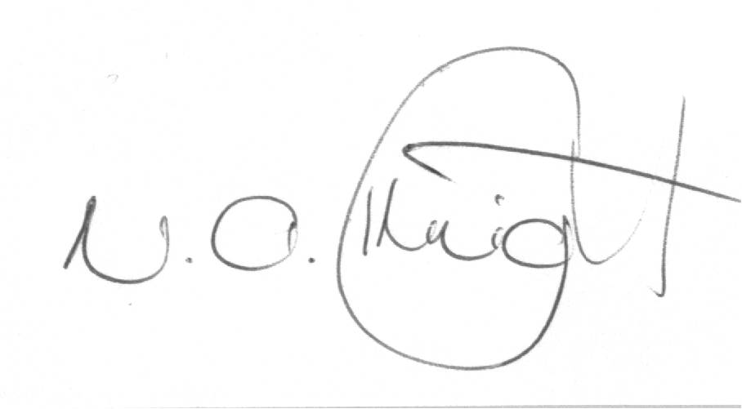

Dr Nicky Knight
The Education Group Ltd
PO Box 26480, Epsom, Auckland
Phone 9202173 or mobile 021420299

