Risky Rock Climbing.
I stood there huffing and puffing, stared at the risky wall while my palms were sweating like a pig.
“I can do this, I can do this,” I thought to myself.
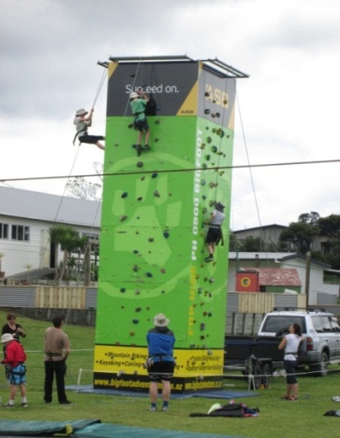
As soon as I put my harness on Mrs. Gleeson, one of the parents called me to do the hardest rock climbing wall out of all three stages. I put my sweaty hand on one of the rocks, turned my hand around and around until I was comfortable. I went up a couple more rocks I felt like a koala climbing a massive tree.
I struggled and tried all I could; I even went onto my tippy toes and tried jumping to the last bar. All I wanted was for me to reach the top; I couldn’t think about anything but completing the climbing wall, but I just couldn’t reach the top. How could I have done better? I think I should have been taller. Hah! Oh well. Does it matter? Maybe next time.
That was one of my best experiences I am good at now.
I wish I could have Year 5 Camp again and have twice as much fun as last time. Hopefully my mum lets me show the Family how spectacular Mangawhai Camp is. By Ashton Evans Werner

