Greedy Tui flew over Snells Beach.
He looked at the Kowhai tree.
Sip, sip, sip
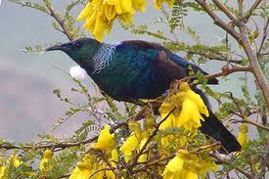
And that was the end of that.

Greedy Tui flew over Snells Beach.
He looked at the puriri tree.
Sip, sip, sip
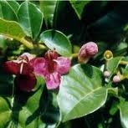
And that was the end of that.

Greedy Tui flew over Snells Beach.
He looked at the rewarewa tree.
Sip, sip, sip
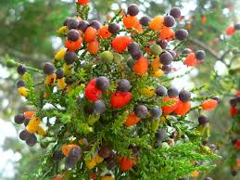
And that was the end of that.

Greedy Tui flew over Snells Beach.
He looked at the Kahikatea tree.
Sip, sip, sip
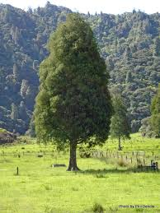
And that was the end of that.

Greedy Tui flew over Snells Beach.
He looked at the pohutukawa tree.
Sip, sip, sip
And that was the end of that.
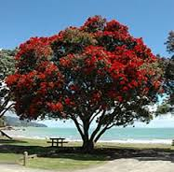

Greedy Tui flew over Snells Beach.
He looked at the harakeke flax.
Sip, sip, sip
And that was the end of that.
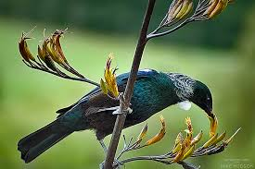

Greedy Tui flew over Snells Beach.
He looked at the rata tree.
Sip, sip, sip
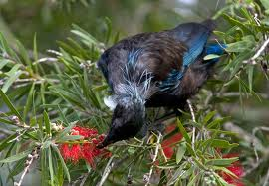
And that was the end of that.

Greedy Tui flew over Snells Beach School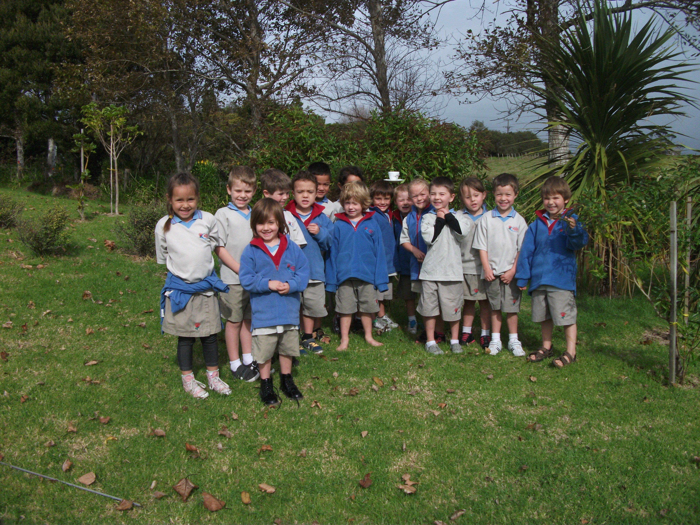.
He looked at the sugar water.
Sip, sip, sip
And that was the end of that.

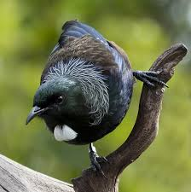
Greedy Tui is Hungry.

