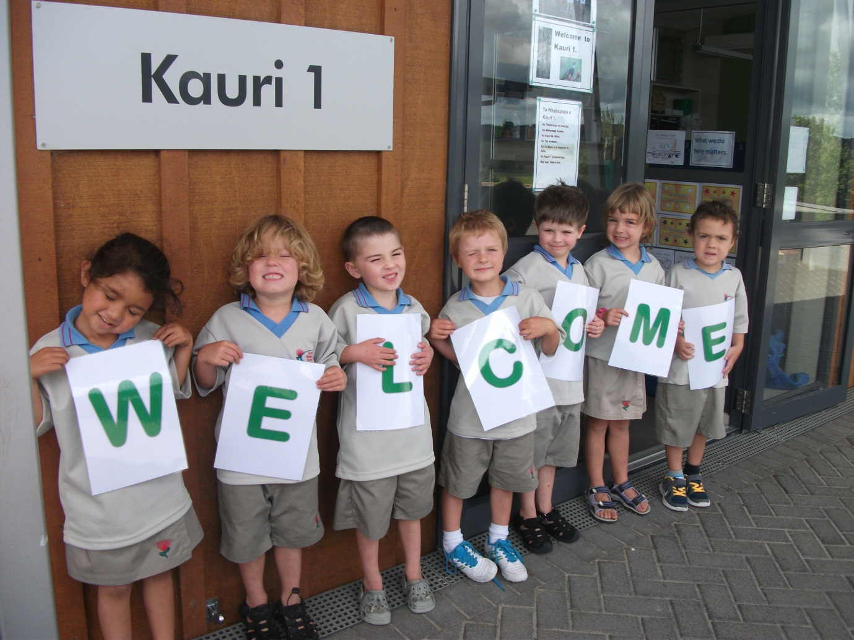***Welcome Wednesday.***

*Key Idea*: To engender a relationship with our families and wider community that is perceived as welcoming, open and transparent.

Organisation

* Each Wednesday afternoon 1.15pm-3pm.
* Kauri 1
* Class will be doing activities that can be joined in and/or observed.
* Parents, siblings, wider family and prospective students and their families will be strongly encouraged to take advantage of this time.
* Advertised in school newsletters, on the web site and in local contributing preschool services.