My Mum
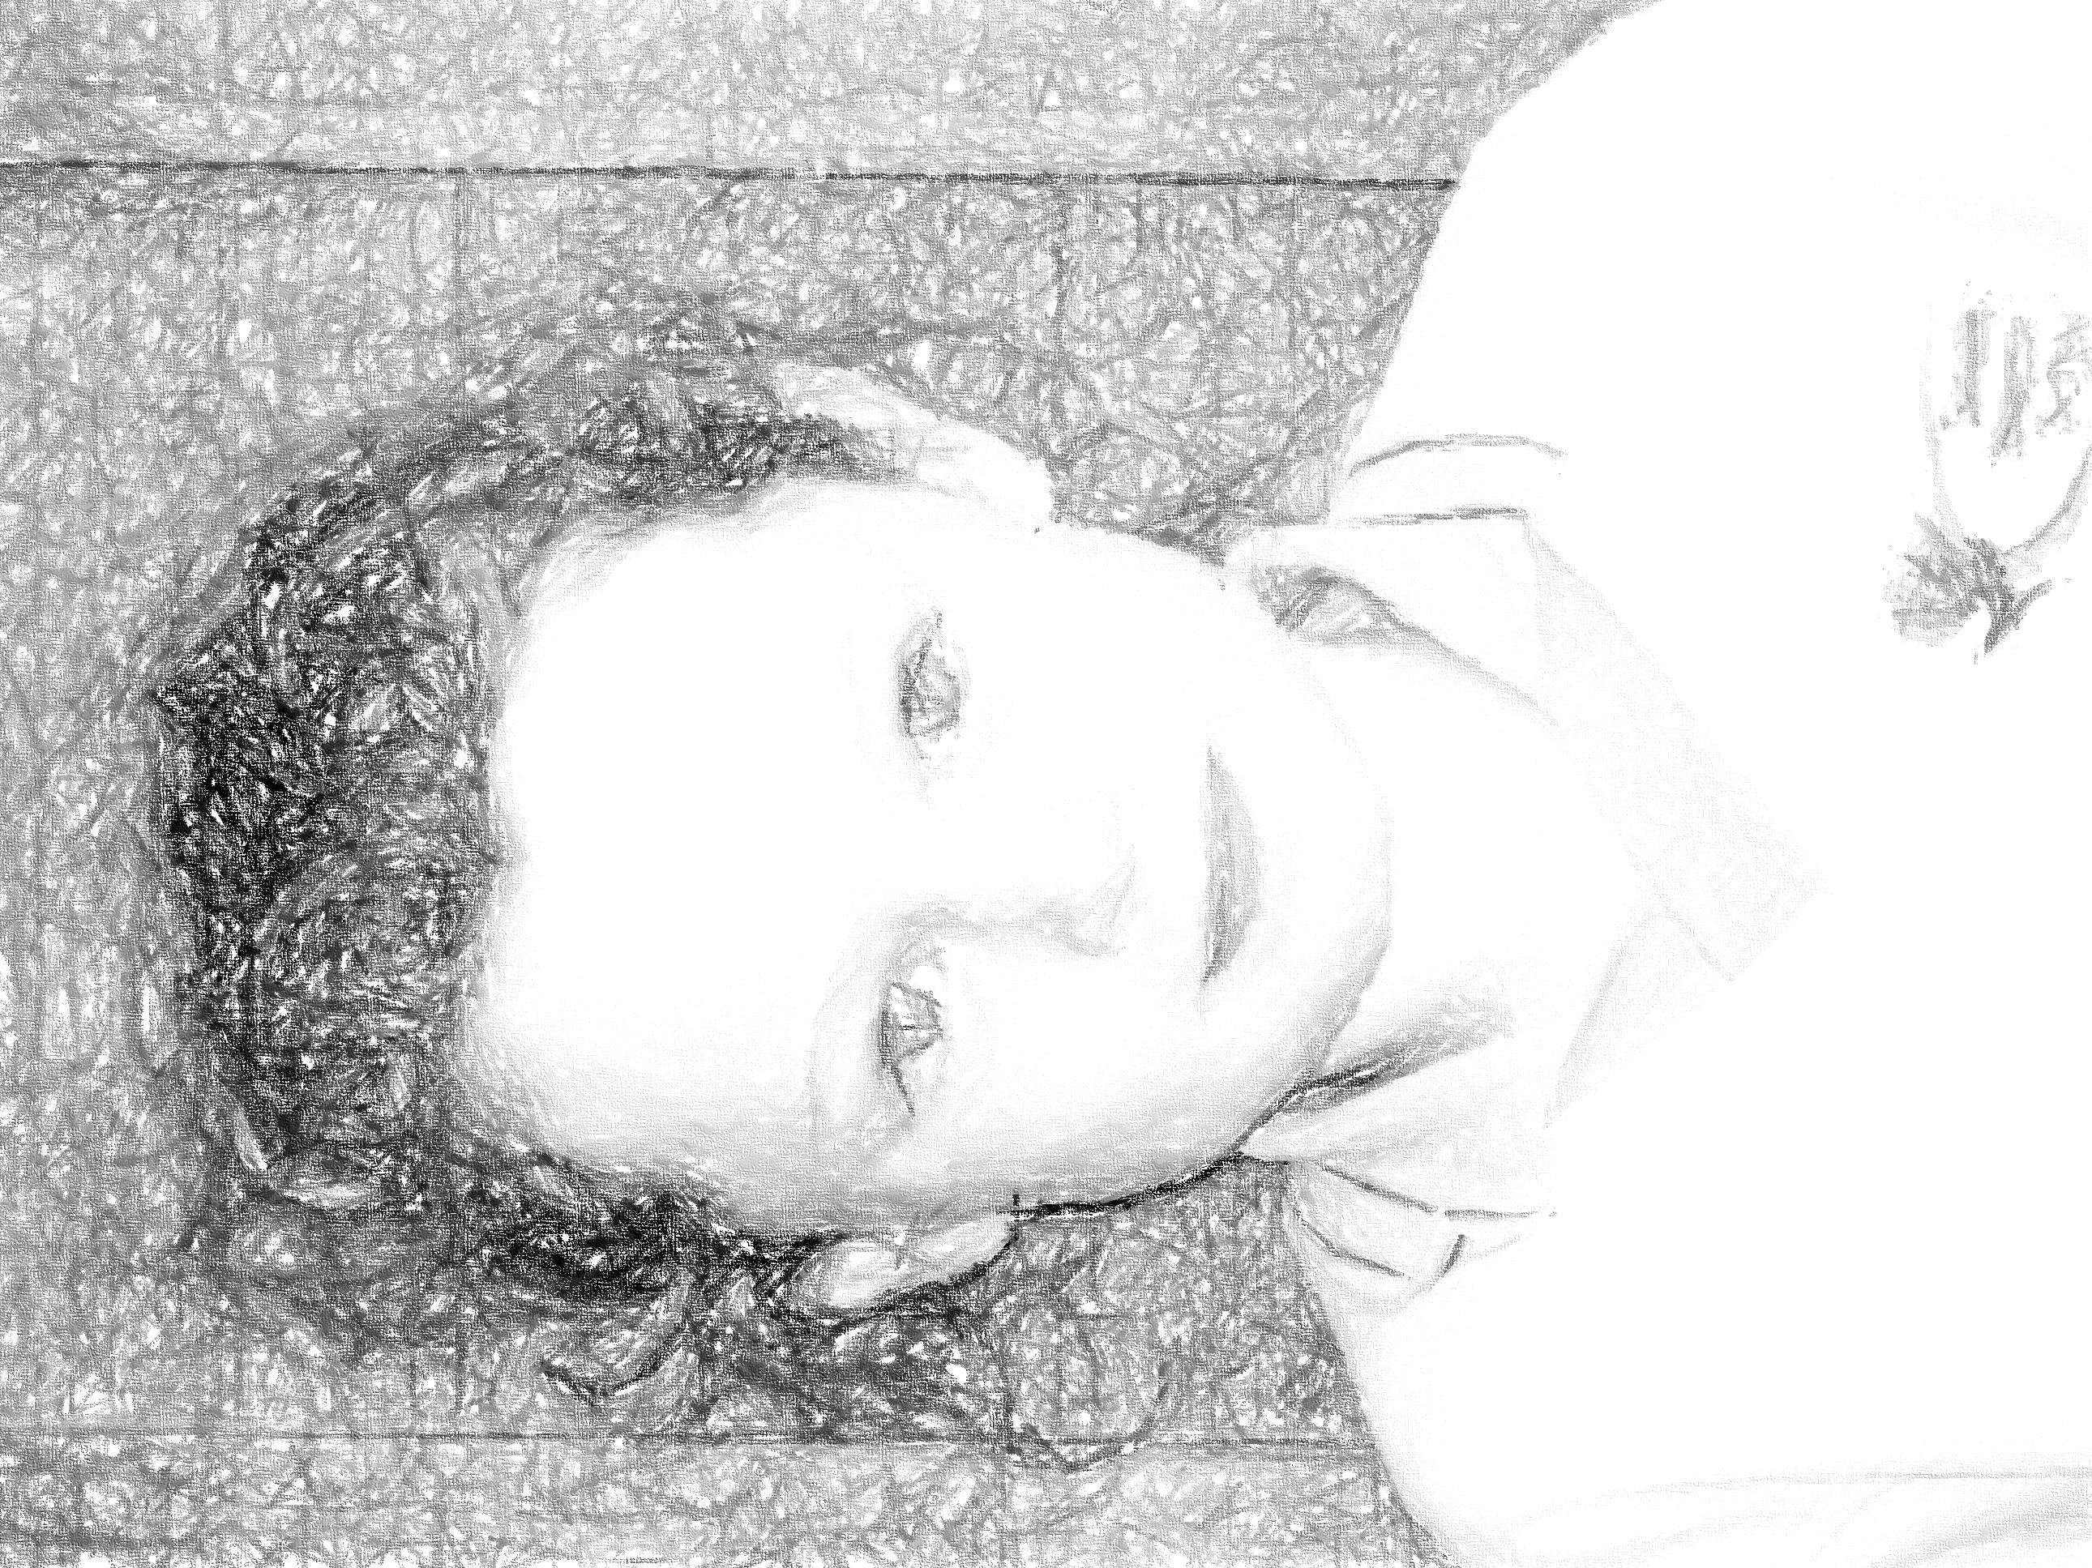
Her smile is beautiful like an angel flying.
Her eyes are shiny like the sunshine in the sky.
Her arms are soft like a pillow
Her hair is long like a world of space.
Her heart is kind like a kiss and a cuddle.
I love my Mum because she is the nicest person in my life.
Isabella

